**JOINS BASICS**

**JOINS** ARE A MECHANISM TO COMPARE TWO OR MORE TABLES & COMBINE THE RESULT INTO A SINGLE OUTPUT. Ex: Course wise Students Ex: Flights wise Reservations

**PURPOSE** : WE USE JOINS FOR DATA ANALYTICS, REPORTING

WE USE JOINS FOR DATA EXTRACTION (E) @ ENGINEERING

**SYNTAX TO JOIN TWO TABLES**:

*SELECT <COLUMN-LIST> | * FROM*

***TABLE1 -- LEFT TABLE***

*<JOIN TYPE>*

***TABLE2 -- RIGHT TABLE***

***ON*** *<JOIN CONDITION>*

**BASIC TYPES OF JOINS:**

**1. INNER JOIN : USED TO COMPARE TABLES, REPORT MATCHING DATA.**

EXAMPLE: COURSES WITH STUDENTS

**2. OUTER JOINS : USED TO COMPARE TABLES, REPORT MATCHING & MISSING DATA.**

EXAMPLE: COURSES WITH STUDENTS, COURSES WITHOUT STUDENTS

2.a - **LEFT OUTER JOIN** : All Left Table + Matching Right Table Data. Non match data is null.

2.b - **RIGHT OUTER JOIN** : All Right Table + Matching Left Table Data. Non match data null.

2.c - **FULL OUTER JOIN** : Combined output of LEFT OUTER JOIN + RIGHT OUTER JOIN.

**3. CROSS JOIN :** USED TO REPORT ALL POSSIBLE COMBINATIONS. NO COMPARISONS.

USAGE: USED IN AUDITTING & QUERY TUNING.

IN LATER CLASSES, WE HAVE EXAMPLES FOR MORE JOINS : SELF JOINS, CROSS APPLY, ETC..

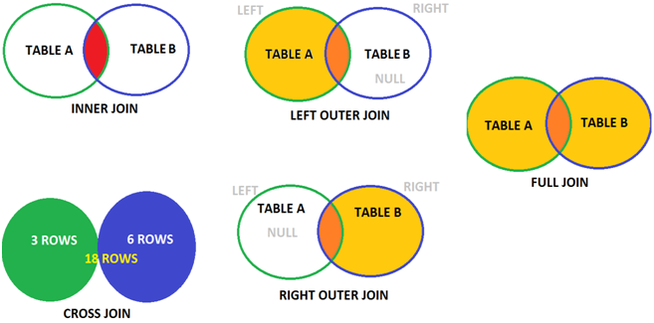

**Cross Join: Each row of 1st table joins with every row of 2nd table.**

